This Document of Understanding outlines the step-by-step procedure for executing the self-billing process in SAP. Each step is accompanied by a placeholder for a screenshot to ensure clarity and ease of execution.
Login To R1E with test user AUTODLL in client 200.
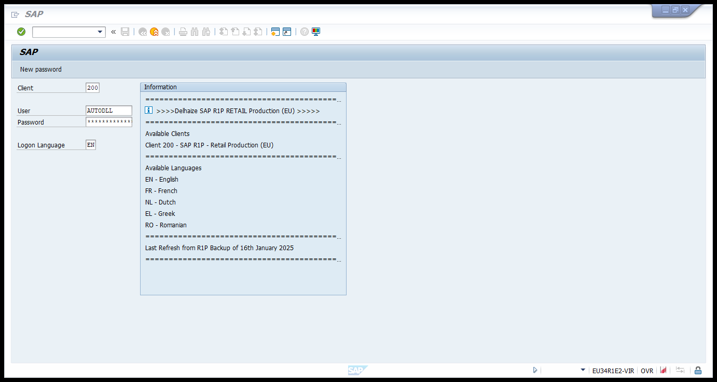

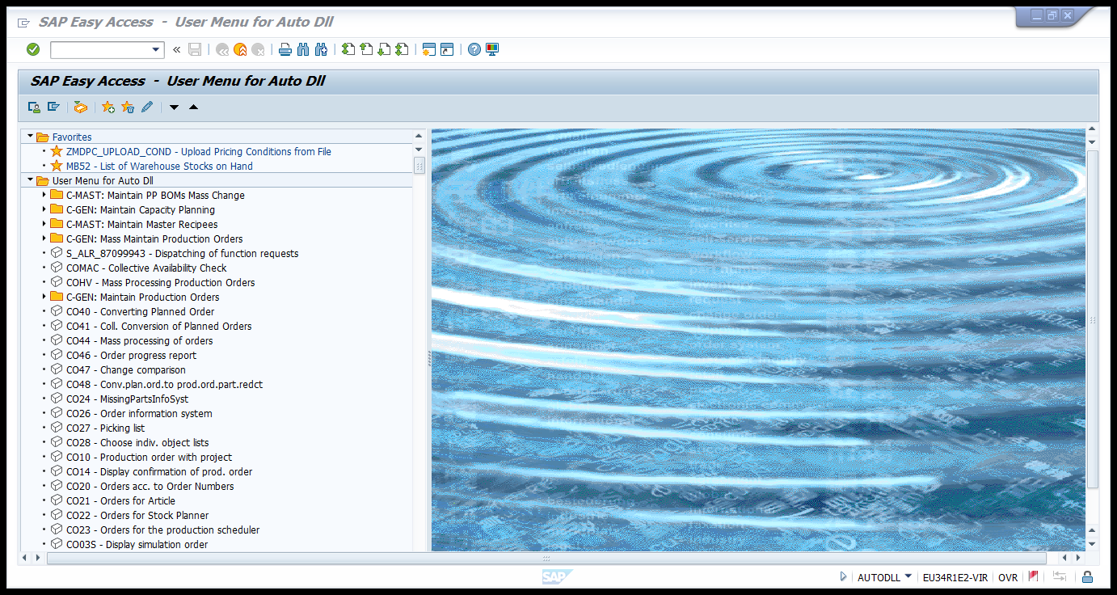

Navigate to the t-code VA01 for creation of the self-billing document.
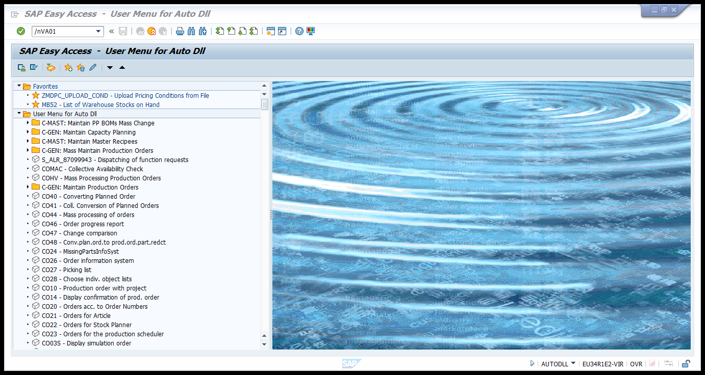

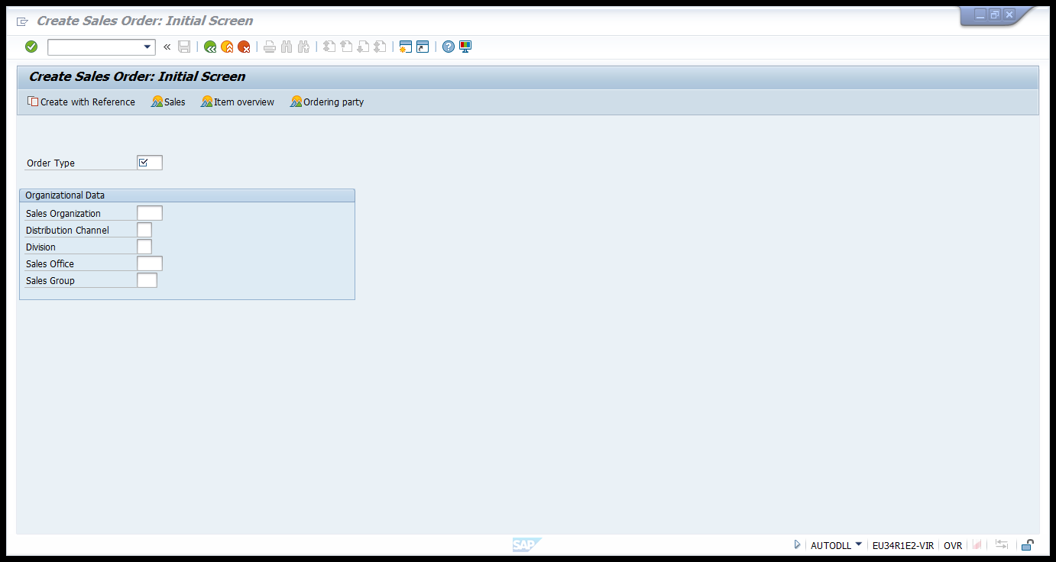

Enter the following details in the following fields and Press Enter.
Order Type: ZSBC
Sales Organization: BS10
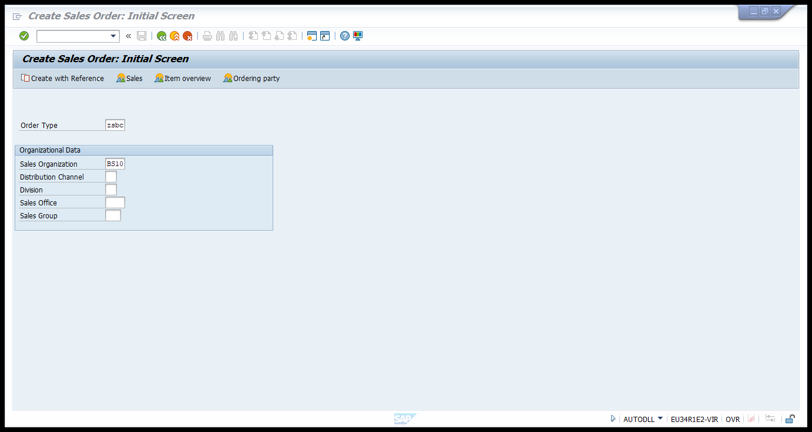
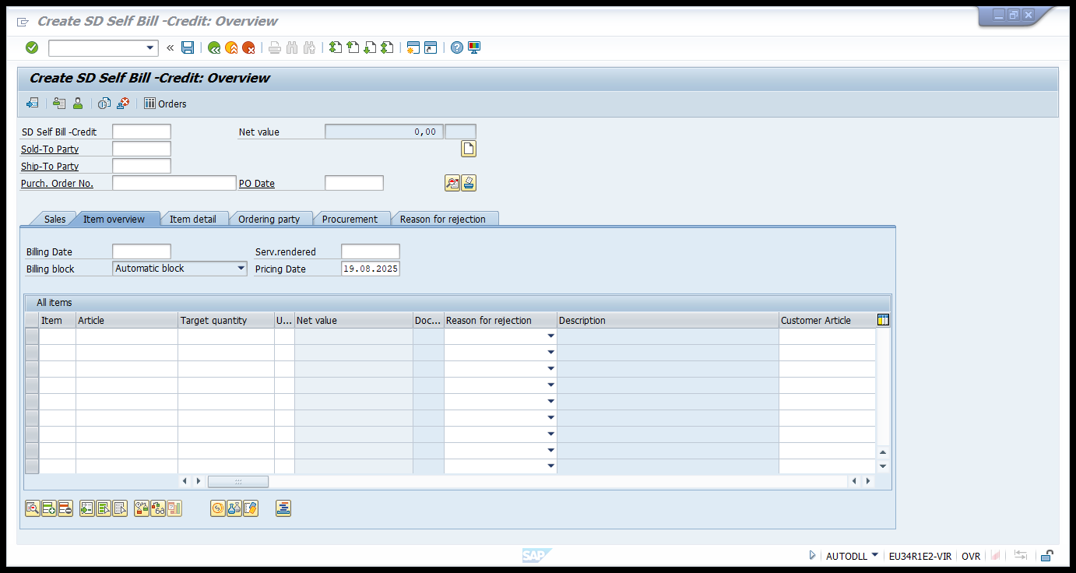

Sold to Party : 11000001
Ship To Party : 11000001
Purchase Order Number – Test_Automation_001(Unique for each run)
Billing Date: 19.08.2025(Today’s Date)
Serv.Rendered: 19.08.2025(Today’s Date)
Pricing Date: 19.08.2025(Today’s Date)
Article: SD10717
Target Quantity : 1
UoM: EA
And Press Enter.
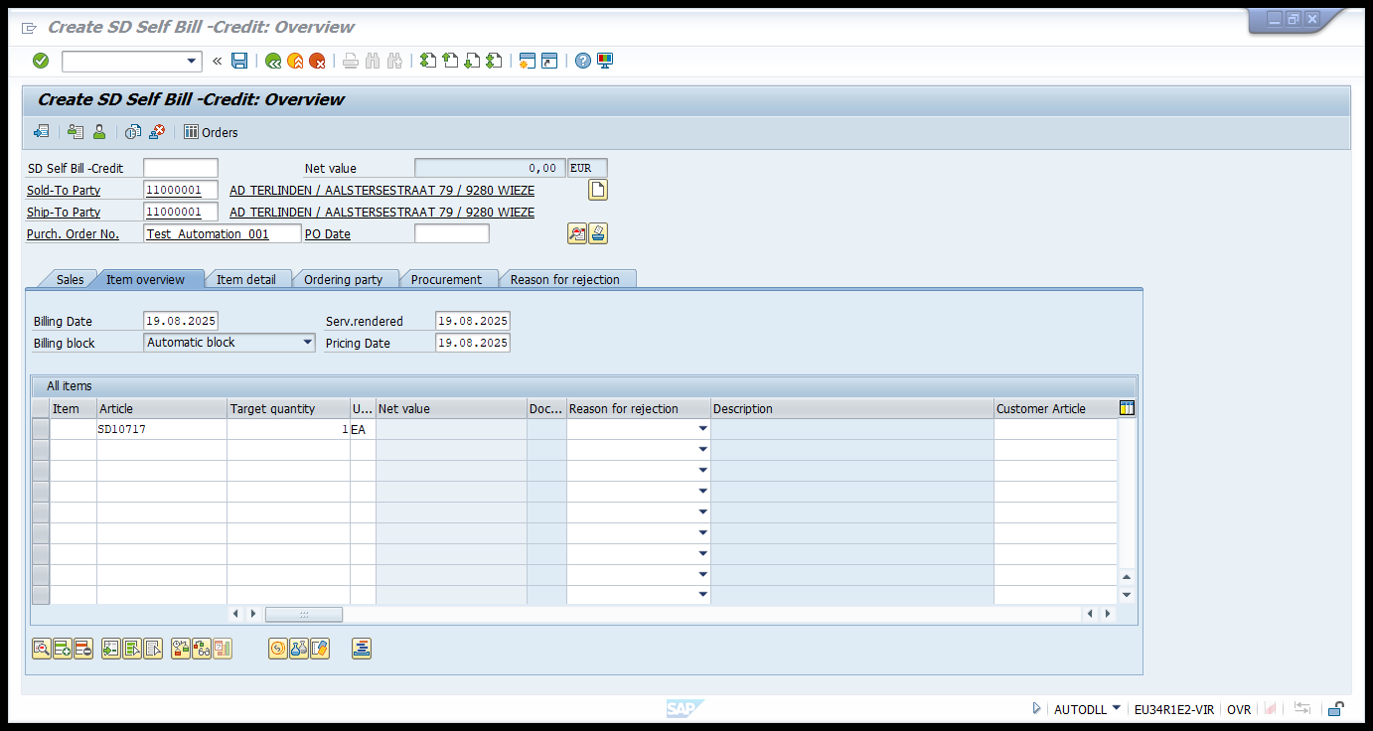

Now Click on Save Button.

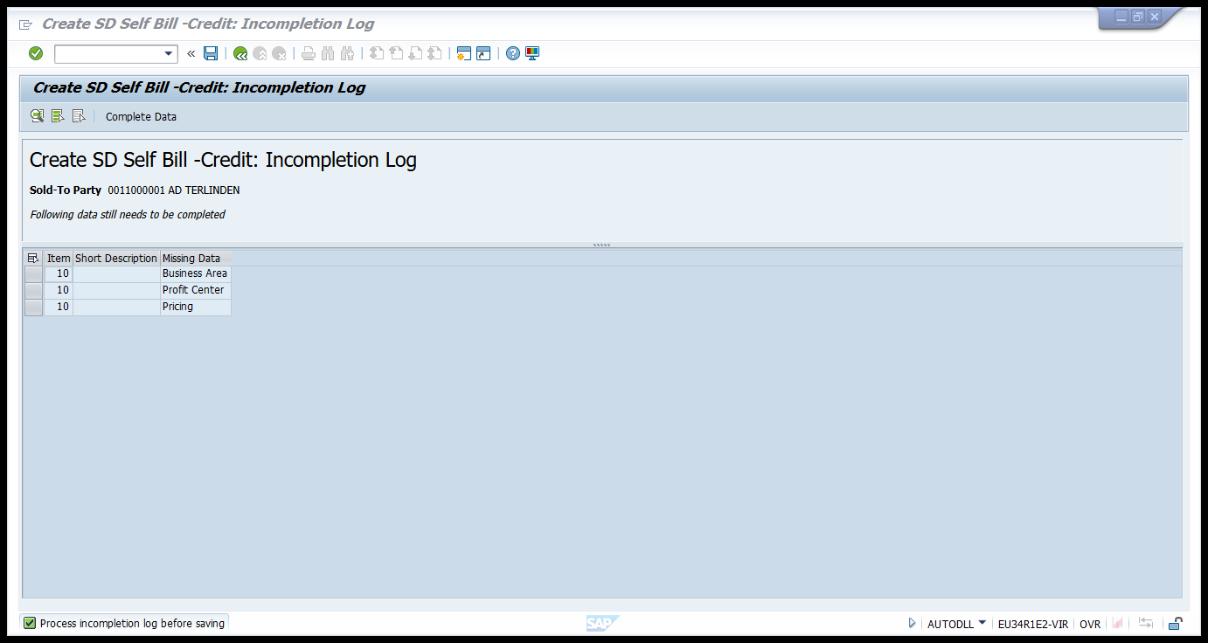
Now Click on Complete Data Button.
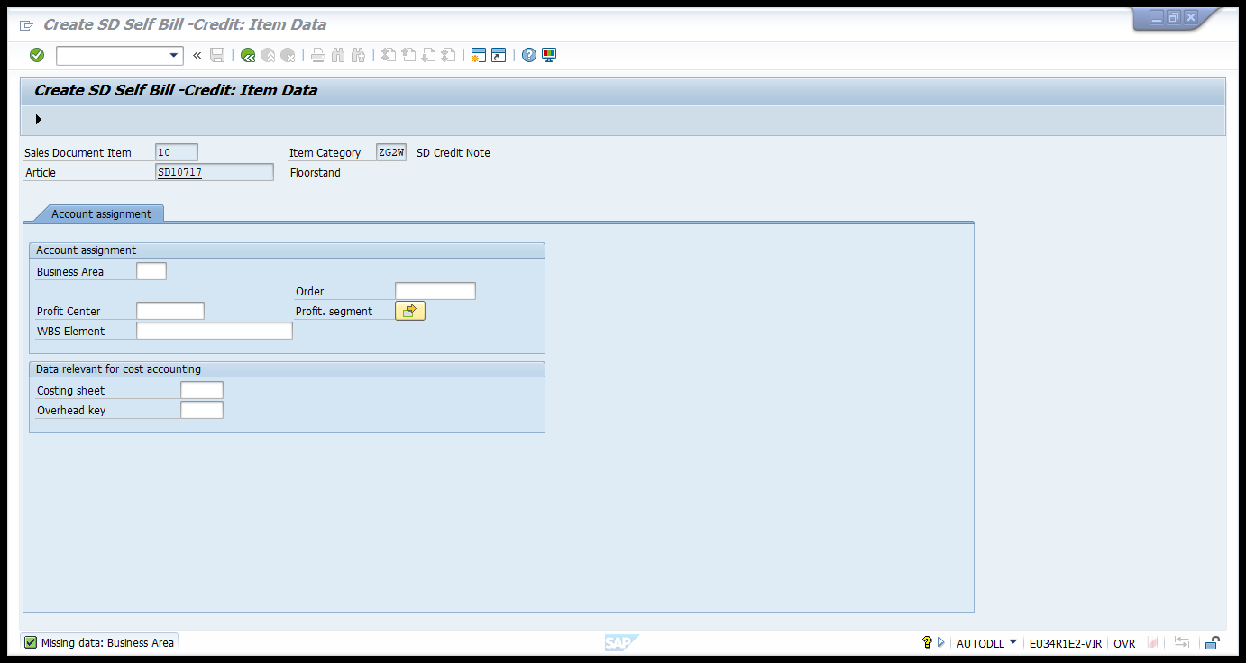

Enter the following Details:
Business Area: A001
Business Area: BS000202.
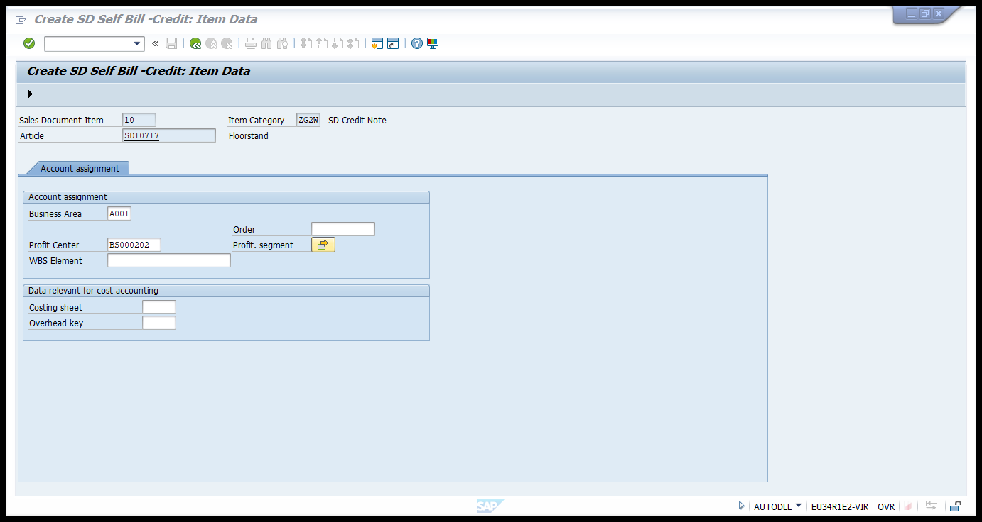
Now Press Enter and Click on Edit Next Data Button.
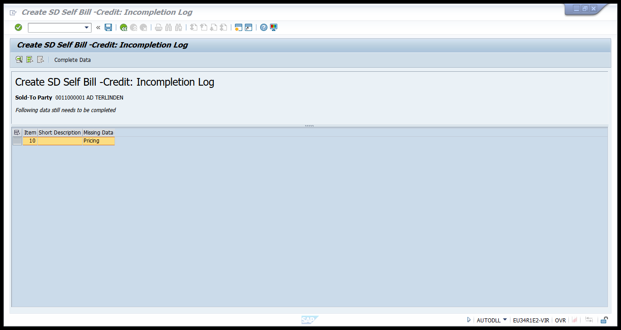

Now Click on Complete Data Button, Enter the price details for the condition.
Amount: 1000
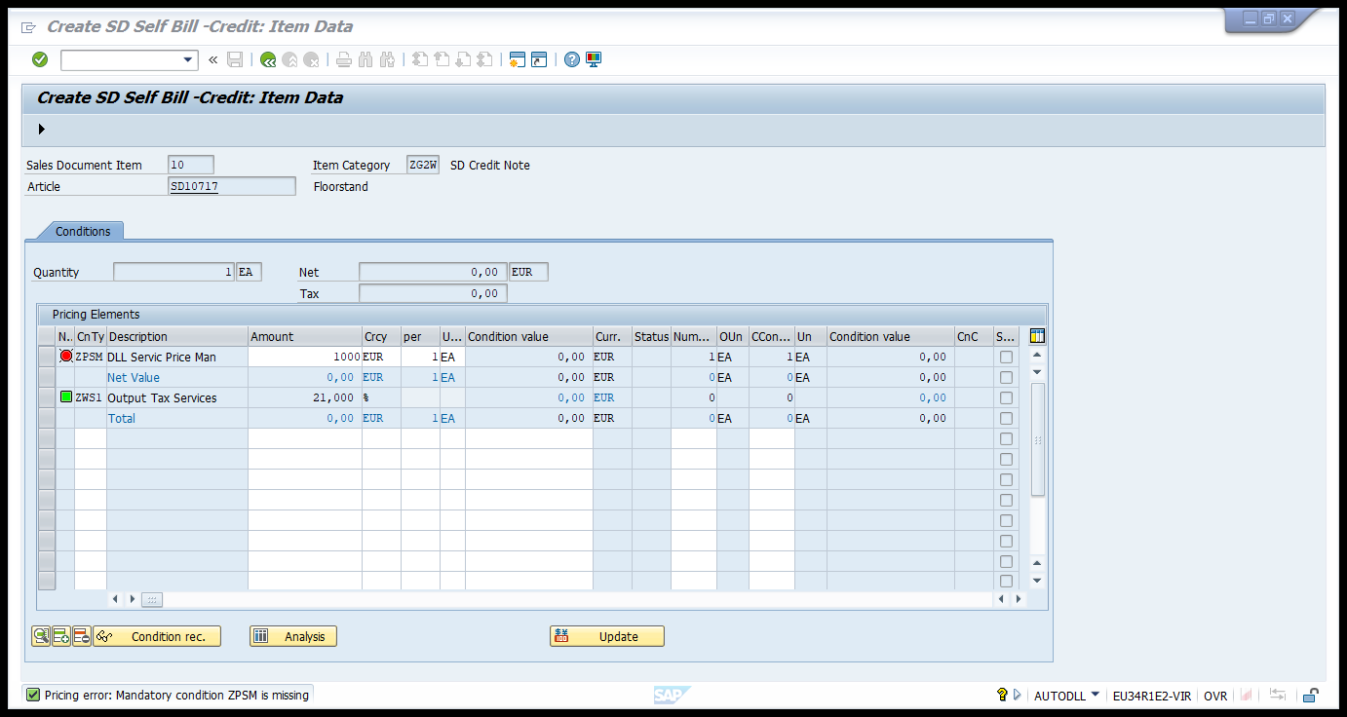
Now Press Enter and Click on Edit Next Data Button.
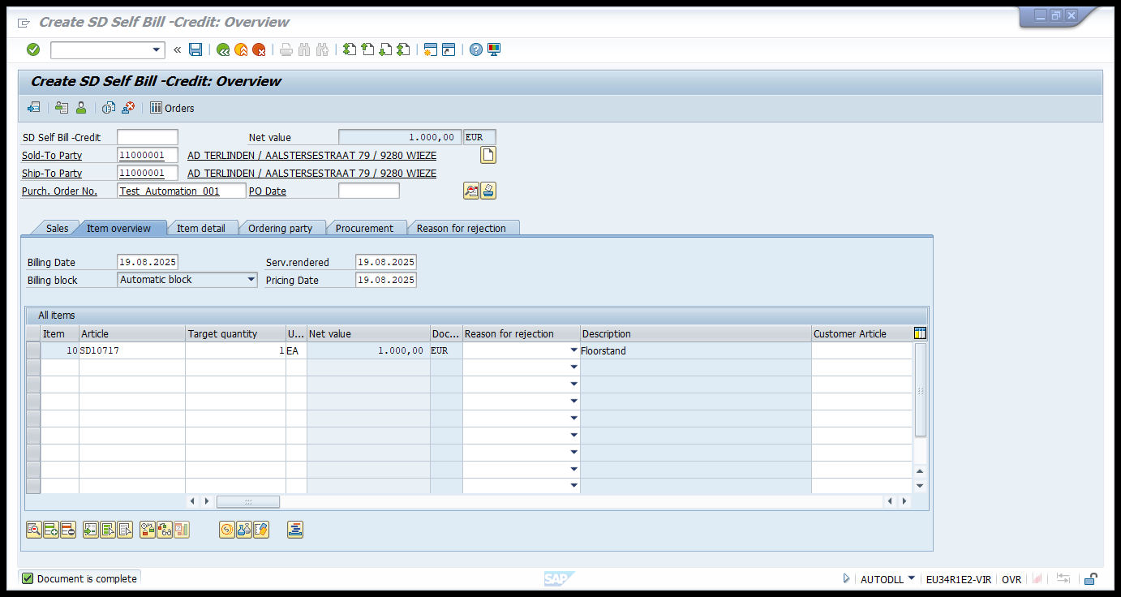

Click on Save button to Complete the creation of SD Document. Now the SD document will be generated.
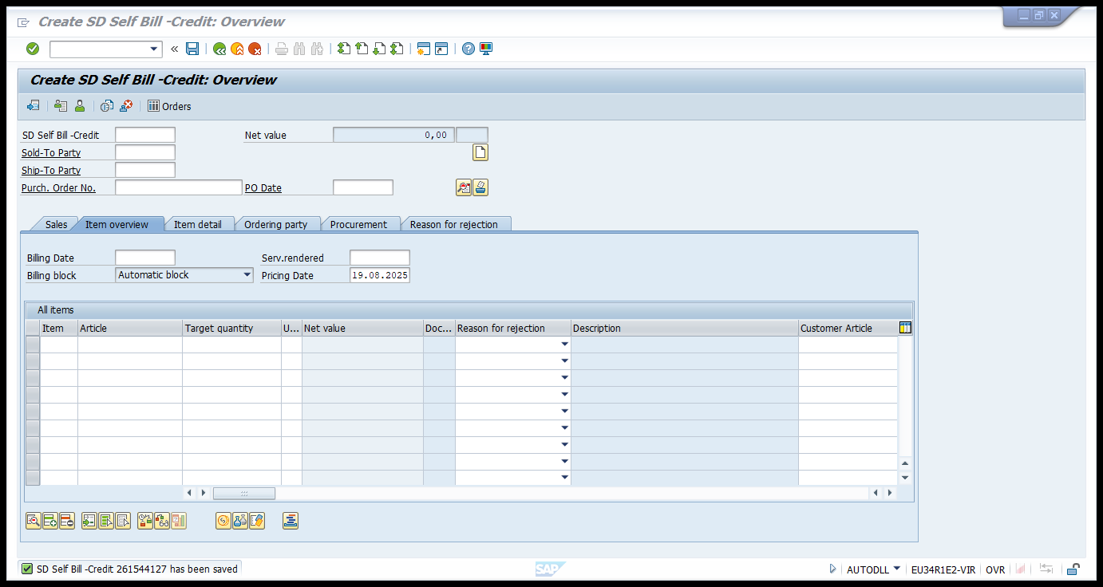
SD Self Bill -Credit 261544127 has been saved.
Step 3: Once SD document - 261544127 is generated we have to Release the document from /nZMDSO_MASS_SO_REJECT
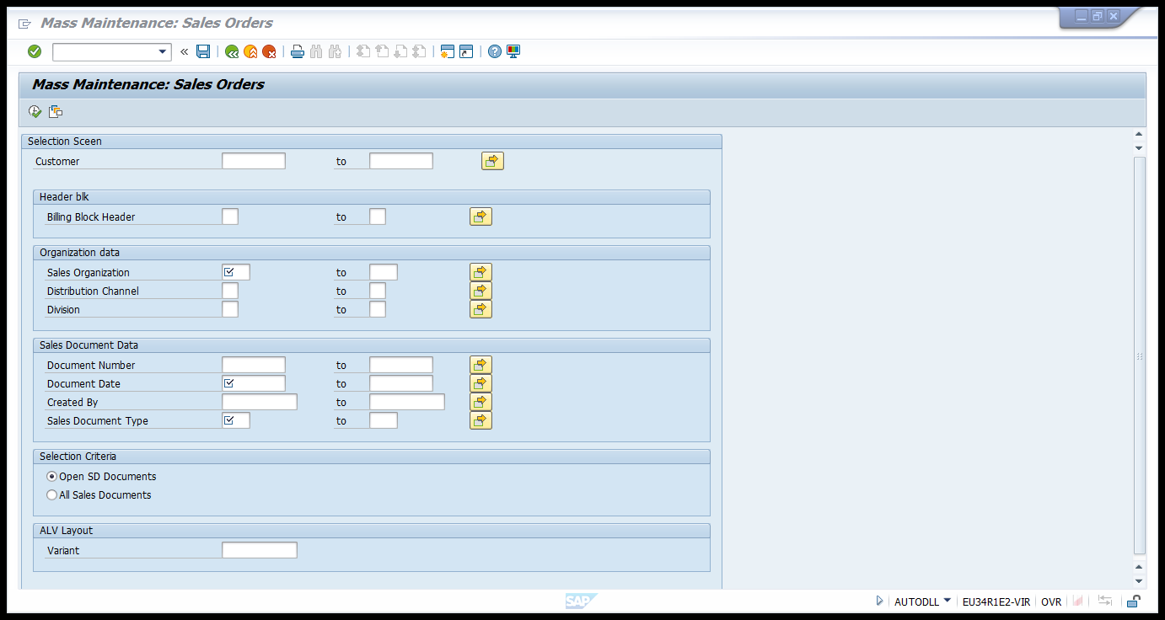

Enter the following Details.
Document Number: 261544127
Sales Organization : BS10
Document Date: 19.08..2025(Creation Date)
Sales Document Type: ZSBC
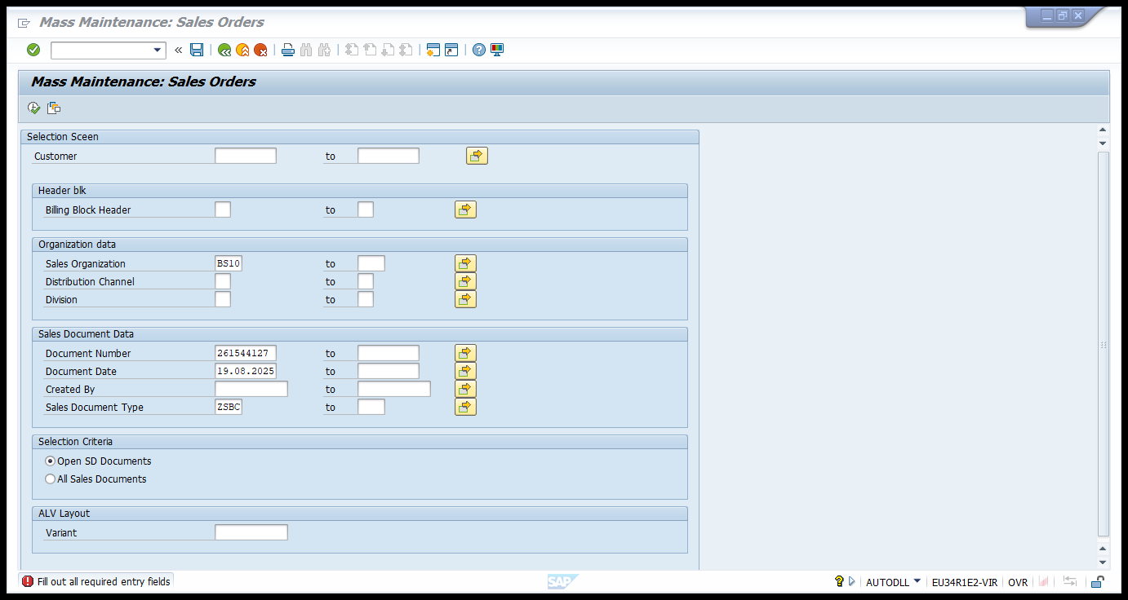
Click on Execute button.
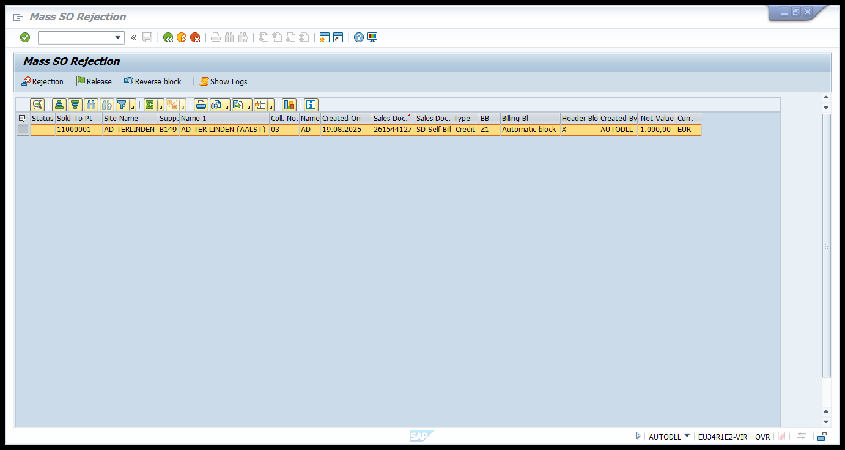

Select the Document and click on Release button to release the blocked SD document.
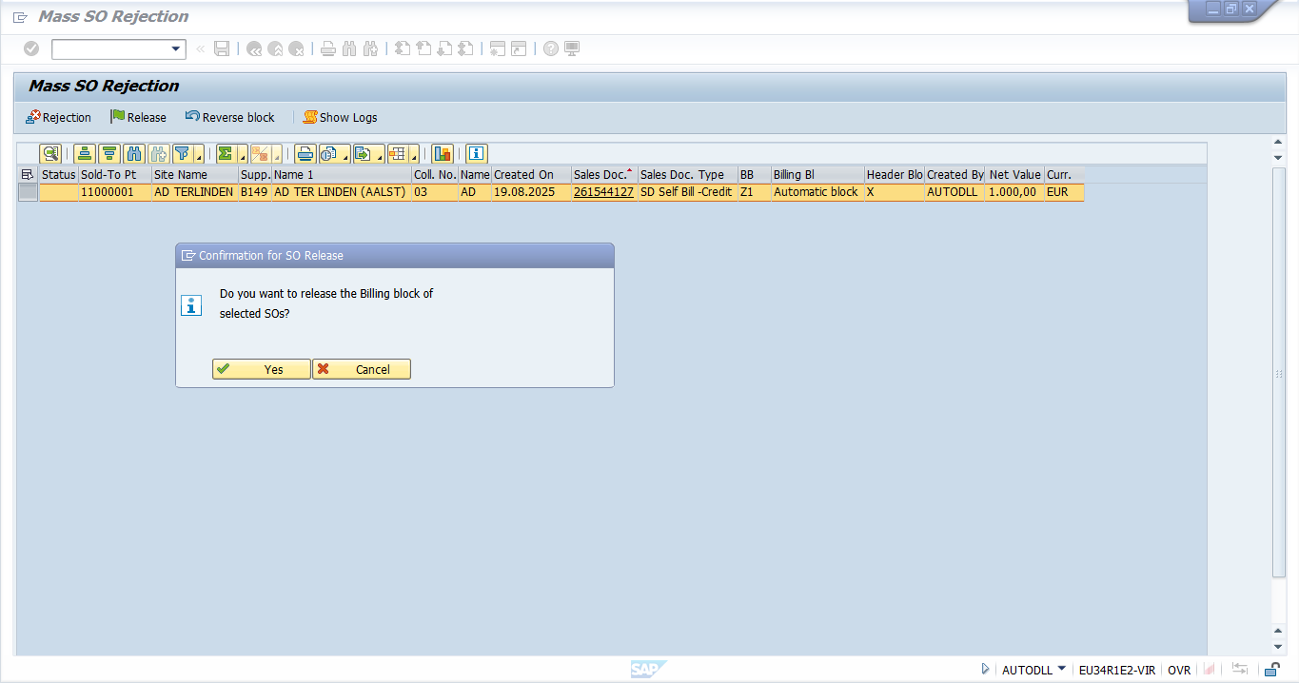
Click on Yes Button on Popup to release the SD Document.
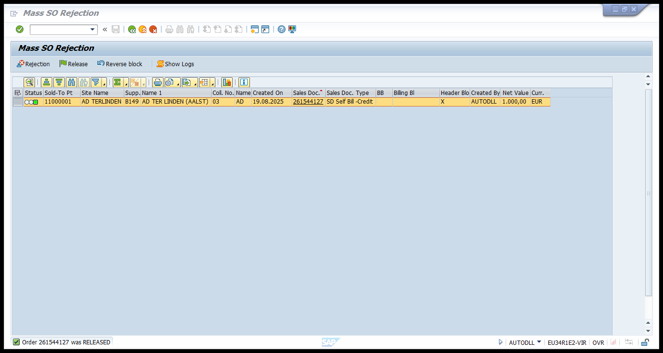

Step 3: Once SD document - 261544127 is generated we have to unlock the document from VF04.
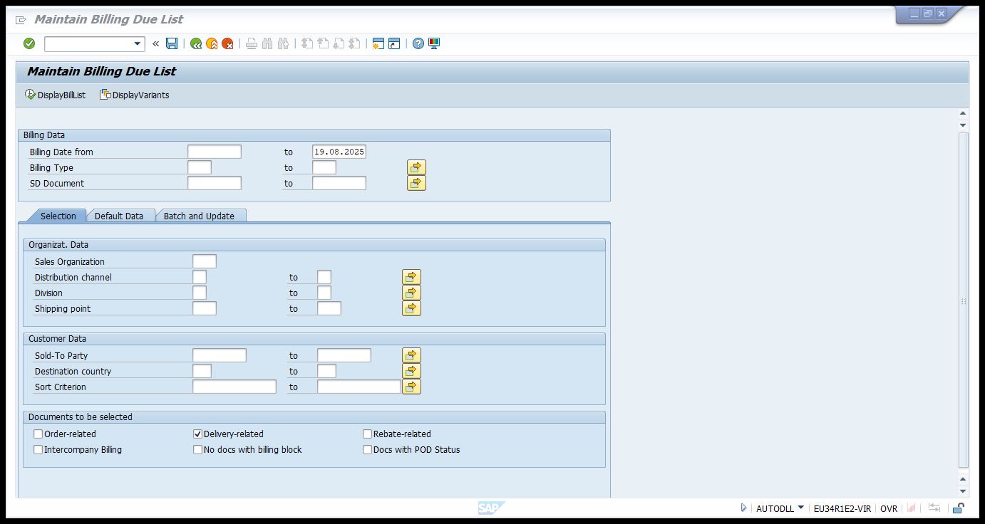
Enter the Following Details.
SD Document – 261544127
Order Related Check box – ON
Rebate Related Check Box - ON
Intercompany Billing Checkbox – ON
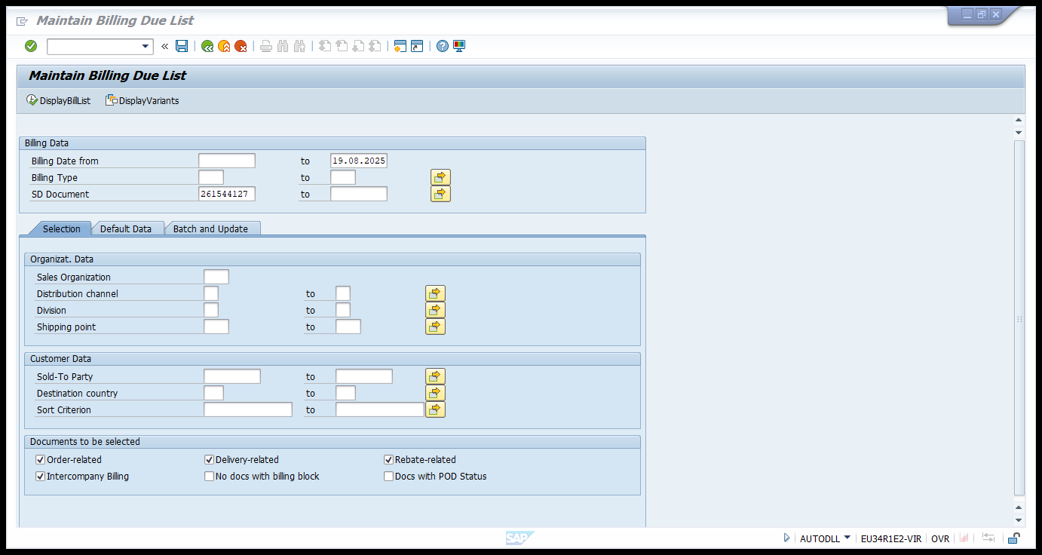

Now Click on Display Billi list button.
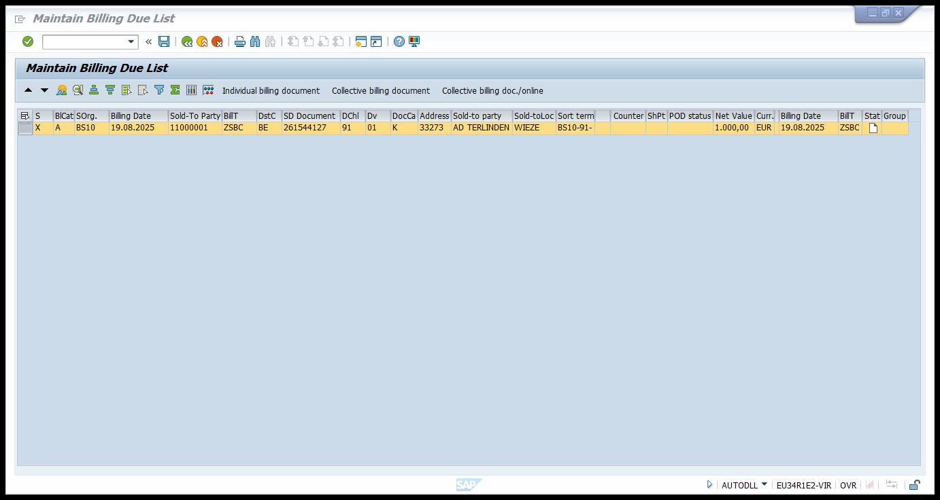
Select the result and click on the Collective billing document to complete the process. Now the status will be change to green color Icon.
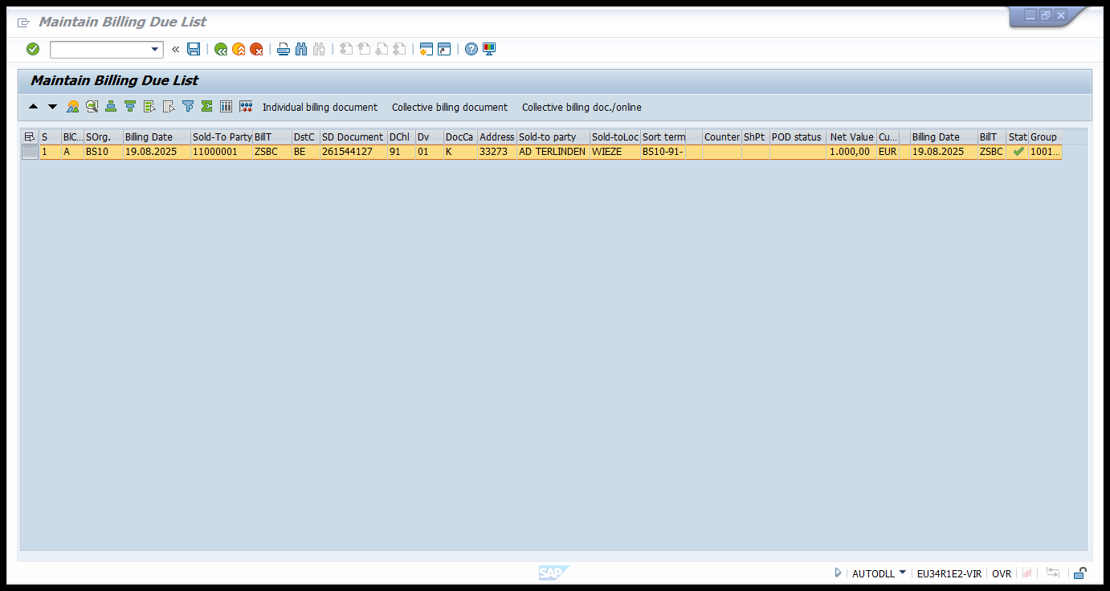

Step 4: Once SD document - 261544127 is Processed we have to verify the billing document is generated via VA03.
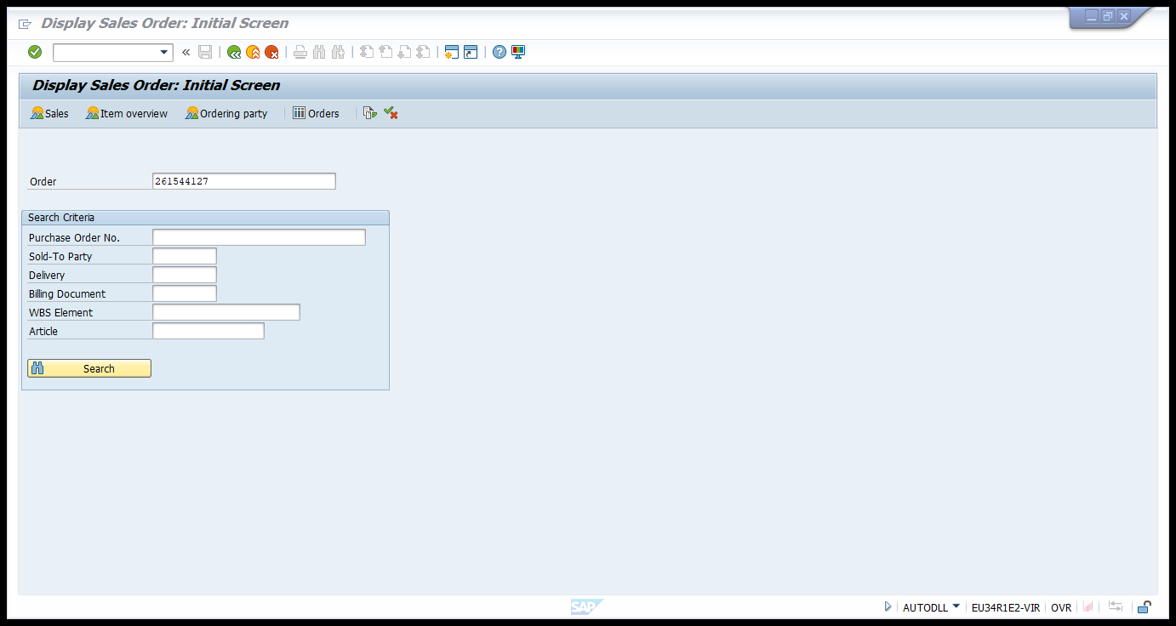
Press Enter.
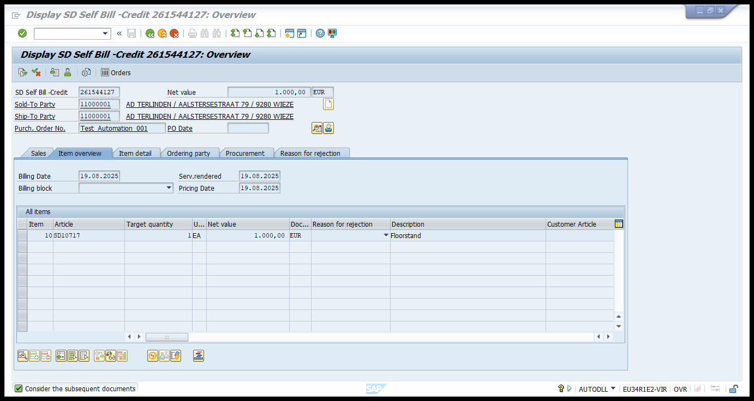

Click on the Display Document Flow Button. The status of the SD is completed, and Billing document is generated.
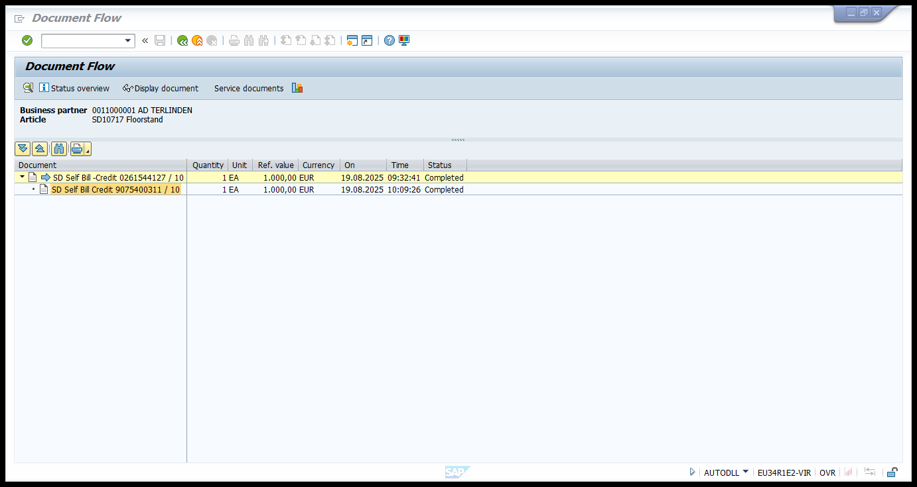
Step 5: Verify the document in BabbleWay.
Now all the documents will be processed to Babble Way.
Login to the Babble Way - Babel way
Select the Self Billing invoices General.
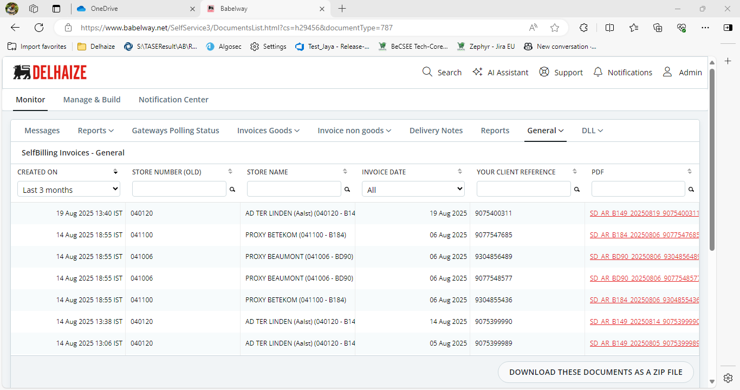

Click on the document generated and check the net value.
